James Reese Europe
Born: February 22, 1881 in Mobile Alabama  Moved: 1891 - Washington D.C. - began musical training  Moved: 1904 - New York to continue his musical training  Founded: 1910 - The Clef Club  Europe was the Clef Club's first elected president as well as the conductor of its symphony orchestra  Appeared: May 2, 1912 at Carnegie Hall  First Recorded: 1913  Joined: 1917 - World War I -At the beginning of the US involvement, Reese joined New York Army National Guard as a private but shortly after passing the officer’s exam was commissioned as a Lieutenant. He was appointed head of an all black military band. His band became known as the 396th U.S. Infantry “Hell Fighters” Band  Returned to US: February 12, 1919  Soon after, they began a tour of American cities and started recording their songs in the studio  Death: May 9, 1919, performed for the last time  Musical Example: On Patrol In No Man’s Land  https://www.youtube.com/watch?v=wpFCuZ-B4j0 | 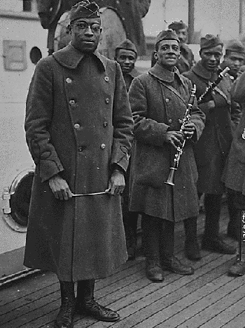
James Reese Europe, one of the first African American to record music in the United States, was born on February 22, 1881 in Mobile Alabama to Henry and Lorraine Europe. When he was ten, his family moved to Washington D.C. where he began to study violin with Enrico Hurlei, the assistant director of the Marine Corps Band. In 1904, Reese moved to New York to continue his musical studies.

In 1910, Europe founded one of the most well known African American organizations during that time, The Clef Club, a part union and part fraternal organization which owned a building on West 53rd Street. Europe was the Clef Club's first elected president as well as the conductor of its symphony orchestra. The Clef Club Orchestra appeared at Carnegie Hall for the first time on May 2, 1912 and later in 1913 and 1914. The Carnegie Hall concerts gave the Clef Club Orchestra respectability in upper class circles and as a result, they were engaged to play at many of the most elite functions in New York, London, Paris, and on yachts traveling worldwide. The Orchestra generated over $100,000 in bookings during the period. In 1913 Europe also made the first of a series of phonograph records for the Victor Talking Machine Company.

At the beginning of World War I, Reese joined New York Army National Guard as a private but shortly after passing the officer’s exam was commissioned as a Lieutenant. He was assigned to the all-black 369th U.S. Infantry Regiment. When his musical background became known he was asked by his commanding officer, Colonel William Hayward, to form a military band as part of his combat unit. Hayward told Europe to get musicians wherever he could, and Reese did just that. Europe knew that it would be difficult to convince musicians in New York to enlist in the military to play music, so he went as far as traveling to Puerto Rico to recruit the needed musicians for his band. His band became known as the 396th U.S. Infantry “Hell Fighters” Band.

The Hell Fighters Band entertained troops and citizens in every city they visited and was received with great enthusiasm. He was sent from the front to lead his band at an Allied conference in Paris where they were only supposed to play one concert. The crowd’s reaction was so great that both American and French officials asked them to stay to perform for eight more weeks.

Europe and his band returned to New York on February 12, 1919. Soon after, they began a tour of American cities and started recording their songs in the studio. Through his music, Europe brought ragtime out of the bordellos and juke joints into mainstream society and elevated African American music into an accepted art form. He was a household name in New York's music world and on the dance scene nationwide. On the final performance of the band’s American tour, Herbert Wright, one of the “percussion twins,” became angered with Europe and attacked him with a knife during intermission. Europe did not survive the attack and Europe was buried with military honors at Arlington National Cemetery.

Legacy: Inspired by James Reese Europe - Blake and Sissle collaborated to create Shuffle Along, the first all-black musical hit on Broadway. The show and its hit songs, “I'm Just Wild about Harry" and "Love Will Find a Way," was so popular that in 1921 the show was performed by three different touring companies
Born: July 10, 1889 in Indianapolis, Indiana  Moved: 1906 Cleveland where young Sissle sang on a vaudeville circuit  Moved: 1915 Baltimore, Maryland where he joined Joe Porter's Serenaders and met his songwriting partner, Eubie Blake.  Enlisted: 1917 - U.S. Army - was assigned to the 369th Infantry Regiment (The Harlem Hellfighters) and formed a military band  Post-War: Sissle and Blake formed “The Dixie Duo” performing on stage without blackface. Among their hit songs in vaudeville was Gee; I'm Glad I'm From Dixie  Death: December 17, 1975  Musical Example: Affectionate Dan  https://www.youtube.com/watch?v=24x0YA_V8a4 | 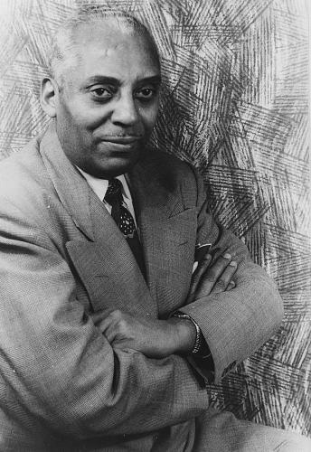  Noble Sissle

Born: February 7, 1883 in Baltimore, Maryland  Moved: 1905 New York where he performed rag-time music in brothels  Returned: 1910, Baltimore, Maryland where he joined Joe Porter's Serenaders and met his songwriting partner, Eubie Blake.  Enlisted: 1917 - U.S. Army - was assigned to the 369th Infantry Regiment (The Harlem Hellfighters) and formed a military band  Post-War: Sissle and Blake formed “The Dixie Duo” performing on stage without blackface. Among their hit songs in vaudeville was Gee; I'm Glad I'm From Dixie  Death: February 12, 1983 (100 years later)  Musical Example: Charleston Rag (Live)  https://www.youtube.com/watch?v=LgYfys7vErI | 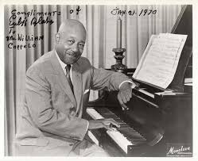  Herbert Eubie Blake

Born: November 25, 1897 in Goshen, NY  Moved: 1914 Newark, New Jersey where he performed with James P. Johnson and Lucky Roberts (all three became known as Harlem’s “Stride Players”)  Enlisted: 1916 - U.S. Army - for his bravery in battle won him the nickname “the Lion.”  Post-War: Soon after Smith returned from France in 1919, he became one of the most influential piano players in New York, mentoring great musicians such as Duke Ellington and Thelonious Monk  Death: February 12, 1983 (100 years later)  Musical Example: Echoes of Spring  https://www.youtube.com/watch?v=ArVhGSY0Spw | 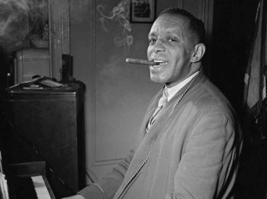  Willie “the lion” Smith

Sources located at www.blackpast.org

