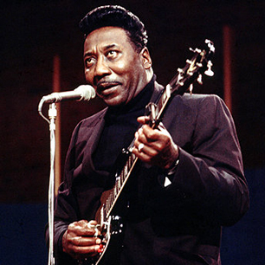 | Muddy Waters  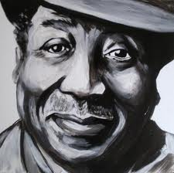 | 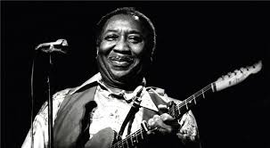

VITAL STATISTICS
Born: April 4, 1915 in Rolling Fork, Mississippi
Joined: the Silas Green Tent Show and began to travel in 1941
Recorded: first to be recorded by Alan Lomax
Moved: to Chicago in 1943 and began performing in clubs
Career Takes Off: In 1950 Aristocrat Records became Chess Records and Waters career took off
Died: April 30, 1983, in Downers Grove, Illinois
Nationality: U.S.
Genre: Blues
Performed as: singer and guitarist
During the performer's lifetime: Mr. Waters was the A & R of Chess Records along with Willie Dixon-bass/ composer, Otis Spann-piano, Little Water-harmonica, Jimmy Rogers-guitar and Elgin Evans-drums. Hits like "I'm Your Hoochie Coochie Man" and "Rollin' Stone" made him an iconic Chicago blues man. Muddy won 6 Grammys.

Early Life - Muddy Waters was born McKinley Morganfield on April 4, 1915, in Rolling Fork, Mississippi, a rural town on the Mississippi River. He was given the moniker "Muddy Waters" because he played in the swampy puddles of the Mississippi River as a boy. His father, Ollie Morganfield, was a farmer and a blues guitar player who separated from the family shortly after Waters was born. When Waters was just 3 years old, his mother, Bertha Jones, died, and he was subsequently sent to Clarksdale to live with his maternal grandmother, Delia Jones. Waters began to play the harmonica around the age of 5, and became quite good. He received his first guitar at age 17, and taught himself to play by listening to recordings of Mississippi blues legends such as Charley Patton. Although Waters spent countless hours working as a sharecropper at a cotton plantation, he found time to entertain folks around town with his music. In 1941, he joined the Silas Green Tent Show and began to travel. As he began to gain recognition, his ambition grew. Then, after Alan Lomax and John Work, archivists/researchers for the Library of Congress Field Recording project caught wind of Waters' unique style, they sought him out to make a recording. The songs "Can't Be Satisfied" and "Feel Like Going Home," were among his first recorded.

Chicago and Mainstream Success - In 1943, Muddy Waters finally picked up and headed to Chicago, Illinois, where music was shaping a generation. The following year, his uncle gave him an electric guitar. It was with this guitar that he was able to develop the legendary style that transformed the rustic blues of the Mississippi with the urban vibe of the big city. Working at a paper mill by day, Waters was sweeping the blues scene by night. By 1946, he had grown so popular that he had begun making recordings for big record companies such as RCA, Colombia and Aristocrat. (He landed a deal with Aristocrat with help of fellow Delta man Sunnyland Smith.) But his recordings with Aristocrat received little recognition. It wasn't until 1950, when Aristocrat became Chess Records that Waters' career really began to take off. With hits like "I'm Your Hoochie Coochie Man" and "Got My Mojo Working," his sensual lyrics peaked interest in the young crowds of the city. "Rollin' Stone," one of his singles, became so popular that it went on to influence the name of the major music magazine as well as one of the most famous rock bands to date.

Later Career - By 1951, Muddy Waters had established a full band with Otis Spann-piano, Little Walter-harmonica, Jimmy Rogers-second guitar and Elgin Evans-drums. The band's recordings were increasingly popular in New Orleans, Chicago and the Delta region in the United States, but it wasn't until 1958, when the group brought their electric blues and began to catch the attention of the rock 'n' roll community. His performance at the 1960 Newport Jazz Festival was a particularly pivotal point in his career, as it caught the attention of a new fan base. Waters was able to adapt to the changing times, and his electric blues sound fit in well with the "love generation." Waters continued to record with rock musicians throughout the 1960s and '70s, and won his first Grammy Award in 1971 for the album They Call me Muddy Waters. After his 30-year run with Chess Records, he went his separate way in 1975, suing the record company for royalties after his final release with them: Muddy Waters Woodstock Album. Waters signed on with Blue Sky Label after the split. He then captivated audiences with his appearance in The Band's farewell performance, known as "The Last Waltz," an exceptionally star-studded affair that was released as a film by Martin Scorsese in 1978.

Death and Legacy - By the end of his lifetime, Muddy Waters had garnered six Grammys as well as countless other honors. He died after suffering a heart attack on April 30, 1983, in Downers Grove, Illinois.

Since his death, Waters' contribution to the music world has continued to gain recognition. In 1997, Waters was posthumously inducted into the Rock and Roll Hall of Fame. Five years later, the National Academy of Recording Arts and Sciences awarded the musician a Lifetime Achievement Grammy Award. Additionally, some of the most recognizable names in music have named Muddy Waters as their single-greatest influence, including Eric Clapton, Jimmy Page, Jeff Beck and Johnny Winter.

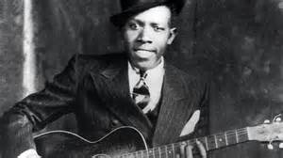 | Robert Johnson  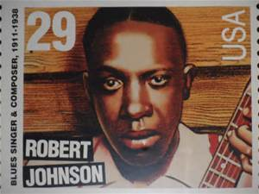 | 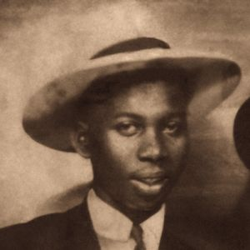

VITAL STATISTICS
Born: May 8, 1911 in Hazlehurst, Mississippi
Died: August 16, 1938 in Greenwood, Mississippi.
Nationality: U.S.
Genre: Blues
Performed as: Songwriter, Singer, Guitarist
During the composer's lifetime: Best known for being one of the greatest blues performers of all time. Son House, a famed blues musician and a contemporary of Johnson, claimed after Johnson achieved fame that the musician had previously been a decent harmonica player, but a terrible guitarist—that is, until Johnson disappeared for a few weeks in Clarksdale, Mississippi. Legend has it that Johnson took his guitar to the crossroads of Highways 49 and 61, where he made a deal with the devil, who returned his guitar in exchange for his soul. His hits include "I Believe I'll Dust My Broom" and "Sweet Home Chicago," which has become a blues standard. Part of his mythology is a story of how he gained his musical talents by making a bargain with the devil. He died at age 27 as the suspected victim of a deliberate poisoning.

Musician Robert Johnson was born on May 8, 1911, in Hazlehurst, Mississippi. A singer and guitarist, Johnson is considered to be one of the greatest blues performers of all time. But this recognition came to him largely after his death.

Career Highlights - During his brief career, Johnson traveled around, playing wherever he could. The acclaim for Johnson's work is based on the 29 songs that he wrote and recorded in Dallas and San Antonio from 1936 to 1937. These include "I Believe I'll Dust My Broom" and "Sweet Home Chicago," which has become a blues standard. His songs have been recorded by Muddy Waters, Elmore James, the Rolling Stones and Eric Clapton.

Mass Appeal - Johnson came to the attention of many musicians and won over new fans with a reissue of his work in the 1960s. Another retrospective collection of his recordings released in the 1990s sold millions of copies.

But much of Johnson's life is shrouded in mystery. Part of the lasting mythology around him is a story of how he gained his musical talents by making a bargain with the devil: Son House, a famed blues musician and a contemporary of Johnson, claimed after Johnson achieved fame that the musician had previously been a decent harmonica player, but a terrible guitarist—that is, until Johnson disappeared for a few weeks in Clarksdale, Mississippi. Legend has it that Johnson took his guitar to the crossroads of Highways 49 and 61, where he made a deal with the devil, who returned his guitar in exchange for his soul.

Strangely enough, Johnson returned with an impressive technique and, eventually, gained renown as a master of the blues. While his reported "deal with the devil" may be unlikely, it is true that Johnson died at an early age.

Death and Legacy - Only 27, Johnson died on August 16, 1938, as the suspected victim of a deliberate poisoning. Several movies and documentaries have tried to shed light on this enigmatic blues legend, including Can't You Hear the Wind Howl? (1997) and Hellhounds on my Trail (2000).

http://www.biography.com/people/robert-johnson-9356324#death-and-legacy

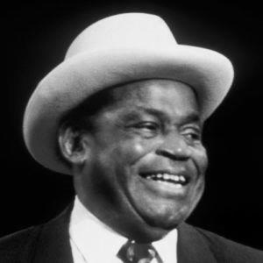 | Willie Dixon  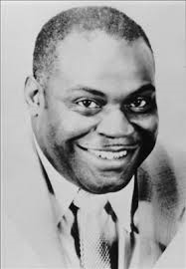 | 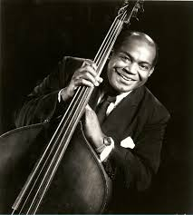

VITAL STATISTICS
Born: July 1, 1915 in Vicksburg, Mississippi, William James Dixon (Willie)
Died: January 29, 1992 in Burbank, California
Moved: to Chicago in 1936
Nationality: U.S.
Genre: Blues
Performed as: Producer, Songwriter, Singer, Bassist
During the composer's lifetime: Willie Dixon has been called “the poet laureate of the blues” and “the father of modern Chicago blues.” He was indisputably the pre-eminent blues songwriter of his era, credited with writing more than 500 songs by the end of his life. Moreover, Dixon is a towering figure in the history and creation of Chicago blues on other fronts. While on staff at Chess Records, Dixon produced, arranged and played bass on sessions for Chuck Berry, Muddy Waters, Howlin’ Wolf, Little Walter and Sonny Boy Williamson, and others. In no small way, he served as a crucial link between the blues and rock and roll. Among his best-known songs are “I'm Your Hoochie Coochie Man” and “I'm Ready,” written for Muddy Waters, and “Little Red Rooster” and “Back Door Man,” for Howlin' Wolf.” Rock performers such as the Rolling Stones, Jimi Hendrix, Elvis Presley and Led Zeppelin recorded his songs.

Early Life - Born in 1915 in Vicksburg, Mississippi, Dixon began rhyming, singing and writing songs in his youth. He was exposed to a variety of music – gospel, blues, country & western – that served as the seeds for the symbiotic music he would later make in Chicago. Moving to the city in 1936, he had a brief career as a boxer and then skirmished with the U.S. Army, refusing induction on the grounds he was a conscientious objector. His early forays on the Chicago music scene included stints with the Five Breezes, the Four Jumps of Jive and the Big Three Trio, all of which made records. The Big Three Trio, in particular, are noteworthy for having brought harmony singing to the blues. Dixon really found his niche at Chess, where he was allowed to develop as a recording artist, session musician, in-house songwriter and staff musician beginning in 1951.

Career Highlights - Some of the now-classic songs he wrote for others during his lengthy tenure at Chess include “Hoochie Coochie Man,” “I’m Ready” and “I Just Want to Make Love For You” (Muddy Waters); “Back Door Man,” “Spoonful” and “I Ain’t Superstitious” and “Wang Dang Doodle” (Howlin’ Wolf); and “My Babe” (Little Walter). Although he didn’t write for Chuck Berry, Dixon played bass on most of his early records. For a few years in the late Fifties, he also wrote for and worked with artists on the crosstown Cobra label, including such fledgling bluesmen as Otis Rush, Buddy Guy and Magic Sam.

Mass Appeal - Dixon returned to Chess in 1959, and the Sixties saw the full flowering of his talents there. In addition to writing and producing some of his greatest works during that decade, he recorded a series of albums in a duet format with Memphis Slim on the Folkways, Verve and Battles labels. His first album, Willie’s Blues, was recorded with Memphis Slim in 1959. He appeared on more recordings with Memphis Slim before releasing his first solo album, I Am the Blues, in 1970. Albums followed from him at more regular intervals in subsequent years, culminating in the 1988 release of Hidden Charms, which won Dixon a Grammy for Best Traditional Blues Recording.

Later Career - In his later years, Willie Dixon became a tireless ambassador of the blues and a vocal advocate for its practitioners, founding the Blues Heaven Foundation. The organization works to preserve the blues’ legacy and to secure copyrights and royalties for blues musicians who were exploited in the past. Speaking with the simple eloquence that was a hallmark of his songs, Dixon put it like this: “The blues are the roots and the other musics are the fruits. It is better keeping the roots alive, because it means better fruits from now on. The blues are the roots of all American music. As long as American music survives, so will the blues.” Willie Dixon published his autobiography, I Am the Blues, in 1989 – a year after Chess Records released Willie Dixon: The Chess Box, a two-disc set that included Dixon’s greatest songs as performed by the artists who’d made them famous – Muddy Waters, Howlin’ Wolf, Little Walter, Bo Diddley, Lowell Fulson – and Dixon himself.

https://rockhall.com/inductees/willie-dixon/bio/#sthash.QWCxVgpY.dpuf

Albert “Sunnyland Slim” Luandrew
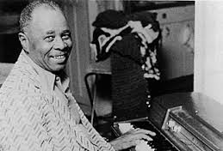 | 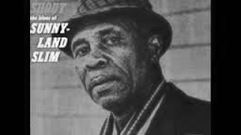 | 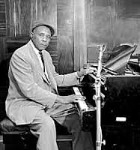

VITAL STATISTICS
Born: September 05, 1907 in Vance, Mississippi
Died: March 17, 1995 in Chicago, Illinois
Moved: to Chicago, IL in 1942
Nationality: U.S.
Genre: Blues
Performed as: pianist, organist and vocalist
During the composer's lifetime: Throughout his career, Sunnyland Slim was highly regarded by his Chicago contemporaries. Among those who recorded with him were Big Bill Broonzy, Muddy Waters, Little Walter, Lonnie Johnson, and bassist Willie Dixon. From 1947 to 1956 Sunnyland had at least one or two releases a year, though they were seldom on the same label. Aristocrat (on which he recorded with Muddy Waters) was followed by Hytone, Mercury, Apollo, JOB, Sunny, Regal, Opera, Chance, Constellation, Blue Label, Vee Jay, Club 51, and Cobra.

Early Life - Albert Luandrew was born September 5, 1907, in Vance, a small Delta town near Clarksdale in the cotton-growing area of northwestern Mississippi. As a boy, he plowed with a mule and did other farm work, but developed an interest in music early. He tried to listen to all the local blues musicians. He taught himself to play piano and organ and began playing in a local church when he was 14. By 1924 he was playing piano in a small movie theater in nearby Lambert, Mississippi. The tall, slender youth soon got the nickname he would keep: Sunnyland Slim.

Career Highlights - In the mid-1920s, Luandrew moved to Memphis to try his hand in the barrelhouses and honky-tonks that lined Beale Street. Memphis remained his home base for 15 years, though he played all over the South. He appeared briefly in Ma Rainey's Arkansas Swift Foot Revue and worked with many important blues artists of the period, including Blind Blake, Blind Boy Fuller, Roosevelt Sykes, Memphis Slim, and Little Brother Montgomery.

In 1942, according to Luandrew, "Memphis got a little rough, and they closed the joints, and they was the places where they had pianos, and you can be damn sure a piano player is going to be closed with them." After working in Missouri for a short time, he got an offer to record in Chicago. He moved there, supporting himself by factory work, truck driving, and an occasional club appearance. The original record deal fell through, and it was five years before he made his first recording. During that time, he established himself as one of the artists who made Chicago virtually synonymous with the blues.

Sunnyland Slim's music never strayed far from its Mississippi Delta origins, though he enjoyed throwing in musical quotations from Count Basie and Duke Ellington. In Chicago he worked extensively with Little Walter and Muddy Waters, as well as with Tampa Red and other musicians in local clubs. He made his first recordings for the Victor label in 1947, but they were released under the cognomen "Doctor Clayton's Buddy," because he was then touring with Peter "Doctor" Clayton.

Later Career - Throughout his career, Sunnyland Slim was highly regarded by his Chicago contemporaries. Among those who recorded with him were Big Bill Broonzy, Muddy Waters, Little Walter, Lonnie Johnson, and bassist Willie Dixon. From 1947 to 1956 Sunnyland had at least one or two releases a year, though they were seldom on the same label. Aristocrat (on which he recorded with Muddy Waters) was followed by Hytone, Mercury, Apollo, JOB, Sunny, Regal, Opera, Chance, Constellation, Blue Label, Vee Jay, Club 51, and Cobra.

Luandrew was an urban bluesman who recorded songs with topical references, such as "Back in Korea Blues," and those with traditional origins, including "Brown Skin Woman" and "Woman Trouble Blues." He had a barrelhouse piano style that augmented the light-textured growl of his singing, sometimes punctuated by a rising falsetto and enhanced by the running monologue he kept up with the audience. About his distinctive approach, he said, "I lay it down hard on the piano. The way I do it, I get a person to tap his foot just like a Baptist preacher." During his later years, he continued to record, performing in festivals and concerts across the United States and abroad.

http://arts.gov/honors/heritage/fellows/albert-sunnyland-slim-luandrew

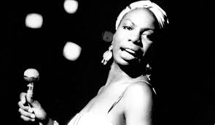 | Nina Simone  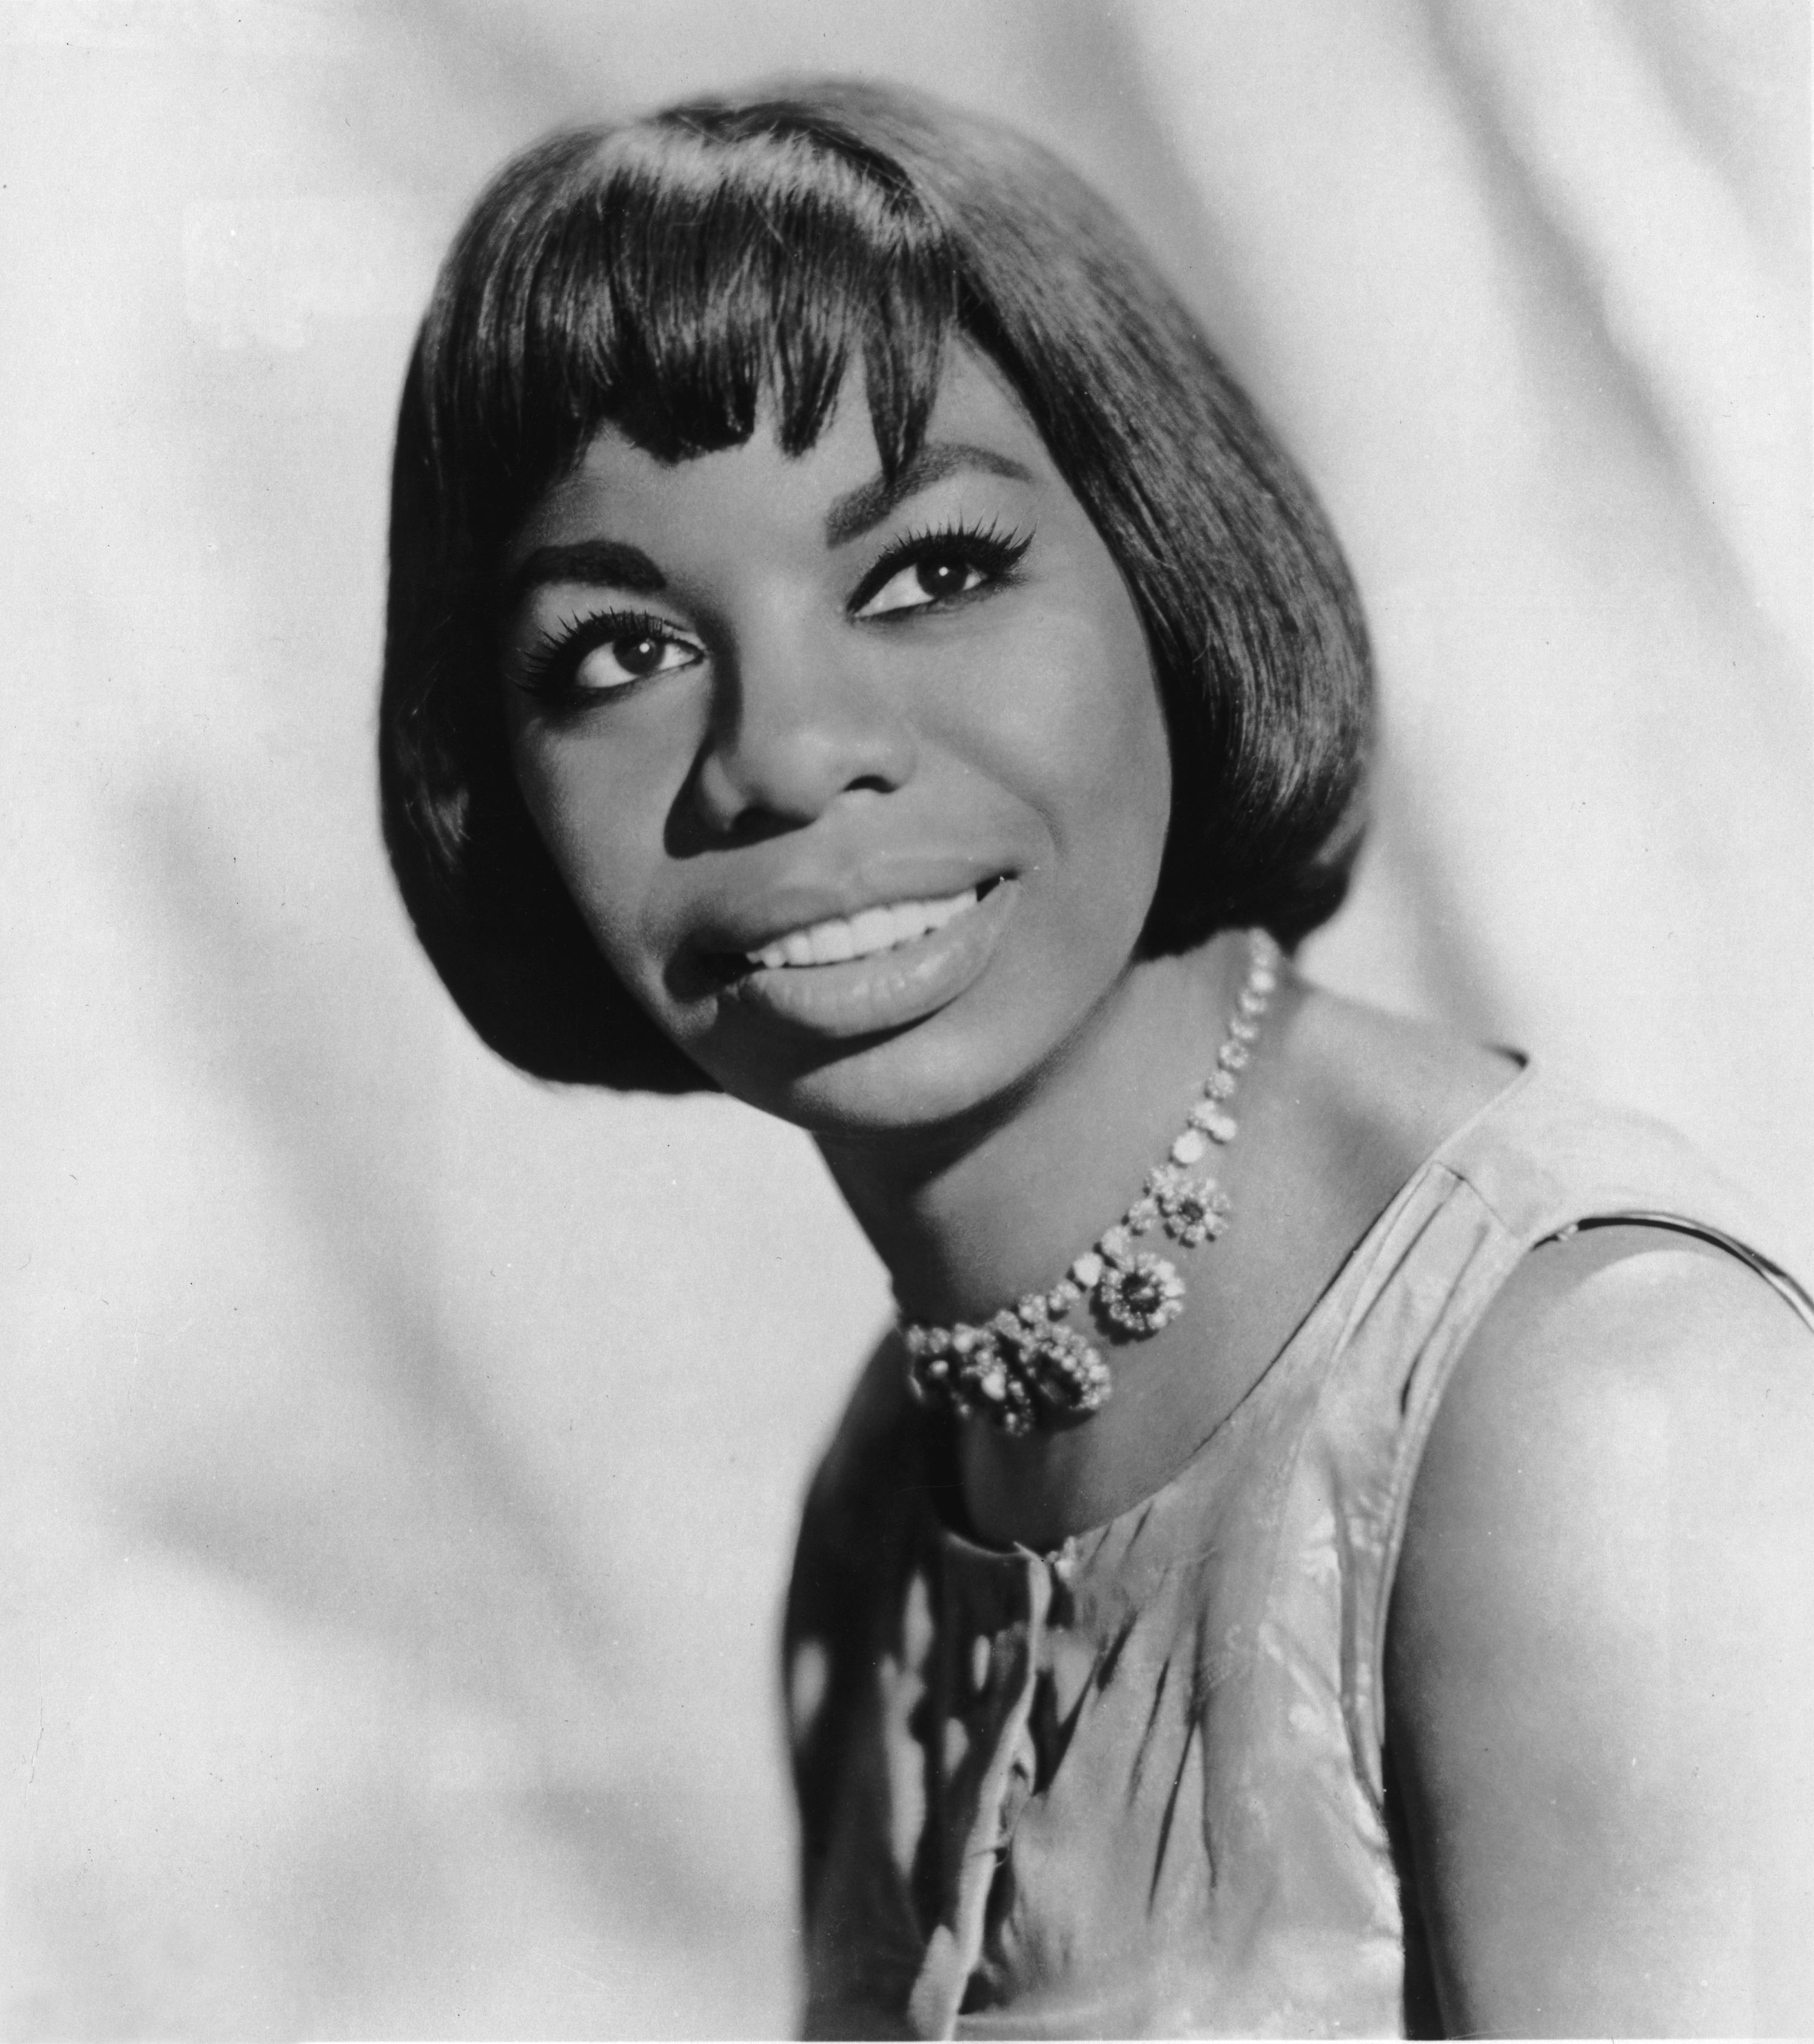 | 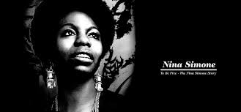

VITAL STATISTICS
Born: February 21, 1933, in Tryon, North Carolina
Died: April 21, 2003 in France
Moved: to New York in 1954
Nationality: U.S.
Genre: Blues, Folk and Jazz
Performed as: Singer, Pianist, Civil Rights Activist and Journalist
During the composer's lifetime: Nina Simone sang a mix of jazz, blues and folk music in the 1950s and '60s. A civil rights activist, she wrote songs promoting the Civil Rights Movement. Nina received a scholarship to study classical piano at the Juilliard School in New York City, but left early when she ran out of money. She turned her interest to jazz, blues and folk music and released her first album in 1958. In the ‘60s, she became identified as the voice of the civil rights and wrote songs about the movement.

Early Life - Born Eunice Kathleen Waymon on February 21, 1933, in Tryon, North Carolina, Nina Simone took to music at an early age, learning to play piano at the age of 4 and singing in her church's choir. The sixth of seven children, Simone grew up poor. Her music teacher helped establish a special fund to pay for Simone's education and, after finishing high school, Simone won a scholarship to New York City's famed Juilliard School of Music to train as a classical pianist.

Simone taught piano and worked as an accompanist for other performers while at Juilliard, but she eventually had to leave school after she ran out of funds. Moving to Philadelphia, Simone lived with her family there in order to save money and go to a more affordable music program. Her career took an unexpected turn, however, when she was rejected from the Curtis Institute of Music in Philadelphia; she later claimed the school denied her admittance because she was African-American. Turning away from classical music, she started playing American standards, jazz and blues in clubs in the 1950s. Before long, she also started singing along with her music at the behest of one bar owner. She took the stage name Nina Simone—"Nina" came from a nickname meaning "little one" and "Simone" after the actress Simone Signoret. She won over such fans as Harlem Renaissance writers Langston Hughes, Lorraine Hansberry, and James Baldwin.

Civil Rights Singer - Simone began recording her music in the late 1950s under the Bethlehem label, releasing her first full album in 1958, which featured "Plain Gold Ring" and "Little Girl Blue." It also included her one and only top 40 pop hit with her version of "I Loves You Porgy" from the George Gershwin musical Porgy and Bess.

In many ways, Simone's music defied standard definitions. Her classical training showed through, no matter what genre of song she played, and she drew from many sources including gospel, pop and folk. She was often called the "High Priestess of Soul," but she hated that nickname. She didn't like the label of "jazz singer", either. "If I had to be called something, it should have been a folk singer because there was more folk and blues than jazz in my playing," she later wrote.

By the mid-1960s, Simone became known as the voice of the civil rights movement. She wrote "Mississippi Goddam" in response to the 1963 assassination of Medgar Evers and the Birmingham church bombing that killed four young African-American girls. After the assassination of Reverend Martin Luther King, Jr. in 1968, Simone penned "Why (The King of Love Is Dead)." She also wrote "Young, Gifted and Black," borrowing the title of a play by Hansberry, which became a popular anthem at the time.

Career Renaissance - As the 1960s drew to a close, Simone tired of the American music scene and the country's deeply divided racial politics. She lived in several different countries, including Liberia, Switzerland, England and Barbados before eventually settling down in the South of France. For years, Simone also struggled with her finances, and clashed with managers, record labels, and the Internal Revenue Service.

Around this time, Simone recorded cover songs of popular music, putting her own spin on such songs as Bob Dylan's "The Times They Are A-Changin'" and the Beatles' "Here Comes the Sun." She also showed her sensual side with the song "I Want a Little Sugar in My Bowl." She then took a break from recording, returning in 1978 with the album Baltimore. The title track was a cover version of a Randy Newman song. Critics gave the album a warm reception, but it did not do well commercially.
Simone went through a career renaissance in the late 1980s when her song "My Baby Just Cares For Me" was used in a perfume commercial in the United Kingdom. The song became a Top 10 hit in Britain. She also penned her autobiography, I Put a Spell on You, which was published in 1992. Her next recording, A Single Woman, came out in 1993. To support these works, Simone gave some performances in the United States.

Touring periodically, Simone maintained a strong fan base that filled concert halls whenever she performed. She appeared in New York City in 1998, her first trip there in five years. The New York Times critic Jon Paneles reviewed the concert, saying that "there is still power in her voice" and the show featured "a beloved sound, a celebrated personality, and a repertory that magnifies them both." That same year, Simone attended South African leader Nelson Mandela's 80th birthday celebration.

Legacy - In 1999, Simone performed at the Guinness Blues Festival in Dublin, Ireland. She was joined on stage by her daughter Lisa for a few songs. Lisa, from Simone's second marriage to manager Andrew Stroud, followed in her mother's footsteps. She has appeared on Broadway in Aida, using the stage name "Simone."

In her final years, Simone battled with health problems. Some reports indicate she was battling breast cancer, but that claim has not been officially confirmed. She died on April 21, 2003, at her home in Carry-le-Rouet, France.

While she may be gone, Simone left a lasting impression on the world of music. She sang to share her truth, and her music still resonates with great emotion and power. Simone has inspired an array of performers, from Aretha Franklin to Joni Mitchell. Her deep, distinctive voice continues to be a popular choice for television and film soundtracks, from documentaries to comedies to dramas.

http://www.biography.com/people/nina-simone-9484532

